# How it Works:

* DeepMIMO v2 dataset generator processes the input ray-tracing file based on the parameters’ values specified in the DeepMIMO parameters file to generate the output.

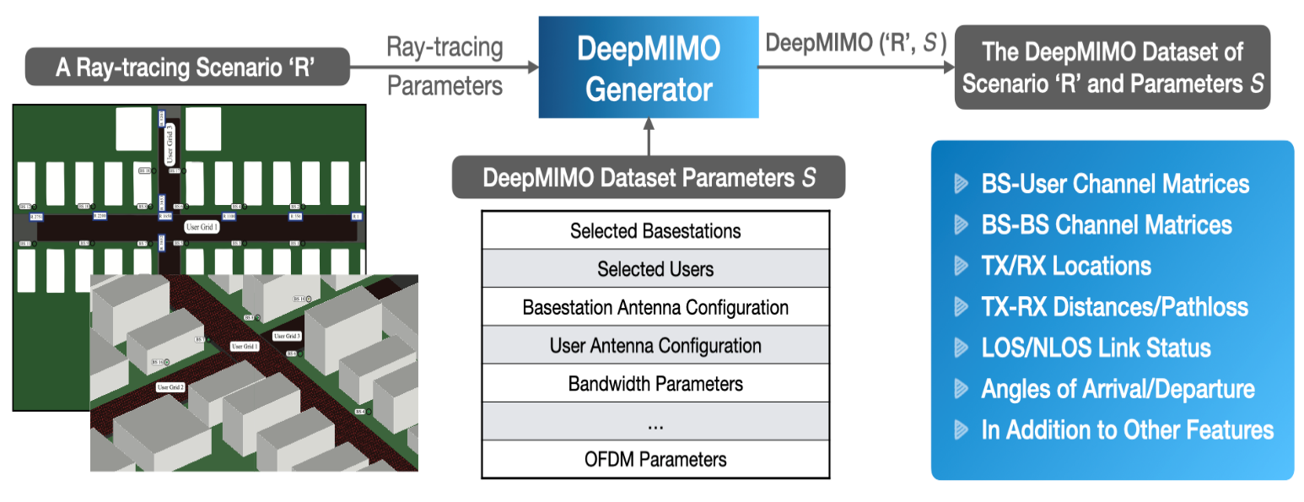

# Download And Installation:

Step 1: Downloading Generator scripts

* Download the DeepMIMO v2 MATLAB generator scripts.
* Click on the link : [Matlab generator script](https://www.deepmimo.net/wp-content/uploads/dlm_uploads/2022/12/DeepMIMOv2.zip)
* Extract the zip file

Step 2: Scenario Files

* Select and download a Scenario from [scenarios page](https://www.deepmimo.net/scenarios/) (The Scenario used in out project is the O1 (Outdoor 1) Scenario using the 28 GHz operating frequency).
* To download 01_28 Scenario : [‘01_28’ Scenario](https://www.dropbox.com/s/7fo0em7fbmd8xd2/O1_28.zip?dl=0)
* Extract the scenario file and paste it into the path DeepMIMOv2/Raytracing_scenarios/

Step 3: Parameter Configuration

* Configure the DeepMIMO parameters in the parameters.m file.

Step 4: Data Generation

* Edit and run the DeepMIMO_Dataset_Generator.m to configure and generate the dataset.

# INPUT PARAMETERS:

**scenario** (string):

* The name of the scenario to be loaded.
* Sample Value: params.scenario = ‘01_28’;

**scene_first, scene_last** (integers):

* For dynamic scenarios, these parameters determine the range of scenes to be loaded.
* Sample Value:

params.scene_first = 1;

params.scene_last = 1;

**active_BS** (integer array of active BSs):

* IDs of the base stations to be included in the dataset. The IDs can be selected from the scenario description and are renumbered starting from 1.
* Sample Value: params.active_BS = [1];

**active_user_first, active_user_last** (integers):

* Determines the range of user rows to be activated. Users with IDs in this range will be selected.
* Sample Value:

params.active_user_first = 1;

params.active_user_last = 1;

**row_subsampling** (float in the range (0, 1]):

* Ratio of rows to be activated within the interval [active_user_first, active_user_last]. A value of 1 activates all rows.
* Sample Value: params.row_subsampling = 1;

**user_subsampling** (float in the range (0, 1]):

* Ratio of users to be activated within the active rows determined by the previous parameters. A value of 1 activates all users.
* Sample Value: params.user_subsampling = 1;

**num_ant_BS** (integer array of 3 dimensions):

* Number of antenna elements in x, y, z dimensions for each active base station.
* Sample Value: params.num_ant_BS = [1, 8, 4];

**ant_spacing_BS** (float):

* Antenna spacing between array elements as a multiple of the wavelength.
* Sample Value:

params.ant_spacing_BS = .5;

params.ant_spacing_UE = .5;

**num_ant_UE** (integer array of 3 dimensions):

* Number of antenna elements in x, y, z dimensions for each active user equipment (UE).
* Sample Value: params.num_ant_UE = [1, 4, 2];

**ODFM Parameters**

* params.num_OFDM = 512; % Number of OFDM subcarriers
* params.OFDM_sampling_factor = 1; % The constructed channels will be calculated only at the sampled subcarriers (to reduce the size of the dataset)
* params.OFDM_limit = 64; % Only the first params.OFDM_limit subcarriers will be considered
* params.saveDataset = 0; % 0: Will return the dataset without saving it (highly recommended!)